**DAILY ONLINE ACTIVITIES SUMMARY**

|  |  |  |  |  |  |  |  |  |
| --- | --- | --- | --- | --- | --- | --- | --- | --- |
| **Date:** | **20-05-2020** | | | | | **Name:** | **Ashwini** | |
| **Sem & Sec** | **6th sem A** | | | | | **USN:** | **4AL17CS017** | |
| **Online Test Summary** | | | | | | | | |
| **Subject** | | **System software and compiler design** | | | | | | |
| **Max. Marks** | | **30** | | **Score** | | | **20** | |
| **Certification Course Summary** | | | | | | | | |
| **Course** | **Introduction to front end development-css** | | | | | | | |
| **Certificate Provider** | | | **greatlearning** | | **Duration** | | | **5hr** |
| **Coding Challenges** | | | | | | | | |
| 1. **Problem Statement:1)** Program to Reverse a Linked List in groups of given size.   **2)** simple Python program to implement Diffie–Hellman Key Exchange Example  3) Java Program which illustrates how to get column properties from ResultSet using  ResultSetMetaData?  4) Python Program to Reverse a Given Number 5) Python Program to Exchange the Values of Two Numbers using ^ (exclusive or operator) | | | | | | | | |
| **Status:completed** | | | | | | | | |
| **Uploaded the report in Github** | | | | | **yes** | | | |
| **If yes Repository name** | | | | | **coding** | | | |
| **Uploaded the report in slack** | | | | | **yes** | | | |

Online Test Details: 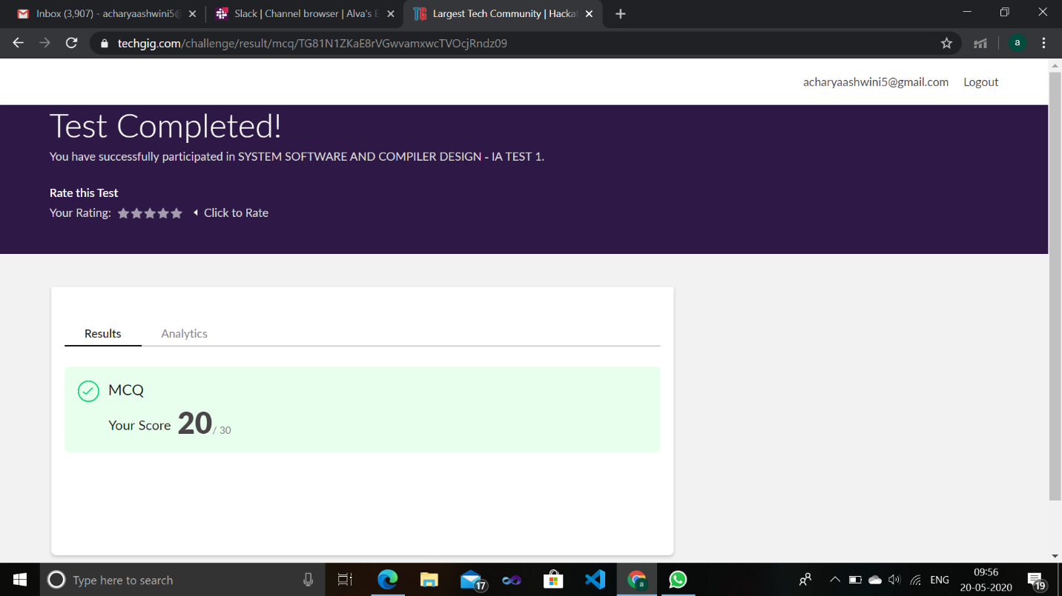

Certification Course Details:

